Public Relations Plan
2013-2014
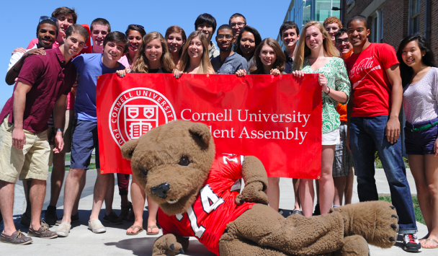

Presented by:
Ian Harris ’16, Vice President of Public Relations
Lindsay Wershaw ’16, Communications Committee Co-Chair
Thomas Hittinger, Communications Committee Co-Chair
Jevan Hutson ’16, Communications Committee

- Purpose
- Image of the Student Assembly
  - Consistency and branding. Be more inclusive. Have students feel invited to join. Reps are known and are actively posting in the constituency group’s page. Accountability - let students know what we’ve done but more importantly what we’re currently working on and how to get involved
- Engaging the student body
  - Creating awareness/improving avenues of communication/increasing interaction. Creating procedure for reaching out to student groups when creating initiative, conducting outreach, or promoting events
- Collaboration with multimedia groups
  - Using their technologies to have individual reps spread our message. Not just a big entity but composed of real students. Use this to get students familiar with reps and comfortable approaching them
- Technology
  - Utilizing student programming skills on campus to make student groups better
  - Initially work with Cornell Dining to create an app
  - Then once we understand the process, timeframe, and costs, adapt these practices to student organizations who can benefit from app development

- Individual Representatives (Representative Action Plan)
- Creation of a Resolution
  - After a rep adds their resolution to the agenda:
  - Type up a short blurb and send it to the VP of PR
“This week, the Student Assembly will be debating “Resolution 16: Revision of Arts and Sciences Government Pre-enrollment”. Currently, students taking Government courses do not know when or if they will have a section in addition to their lecture until after classes have begun. The Student Assembly will debate whether to recommended to the Government department that their discussion section registration occur during regular course enrollment, as is consistent with other departments in Arts and Sciences. If approved by the Government department and the Student Assembly, these changes take effect by course enrollment for Fall 2014. For questions or further information please reach out to Arts and Sciences Representative Brandon Thompson at brt36@cornell.edu.”
  - Figure out which groups your initiative may affect by talking with VP Outreach as well as do research on Orgsync.com site
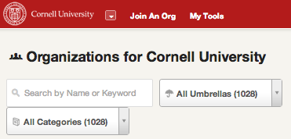

  - Find all applicable organizations that potentially may be affected by the resolution – no group is too big or small. The page contains contact info for officers (President, VP).

  - Send an email to the President and VP of the organization informing of them of your resolution (using official letterhead above)
    - Ask that they forward it to the group’s listserv so all members are aware of potential changes. Invite officers and group members to ask questions, meet with you during SA Office hours each Wednesday or Thursday, and invite them to attend the SA Meeting and vote on the resolution (explain the Community Clause).
      - The point of sending event information that corresponds to a group’s interests is that more students will be informed and willing to attend SA Meetings on issues that affect them. It is more impactful if a group is invited by their rep, rather than solely from the entity of the Student Assembly. This act of using student groups and the university’s student organization’s website including OrgSync, truly allows for SA members to interact with groups on a rep-organization level and adds a personal touch to invitations to attend the meetings.
  - Post announcement to the Facebook page
    - State their upcoming resolution is coming before the SA, tag any organizations that might be affected
  - When a rep’s resolution is passed:
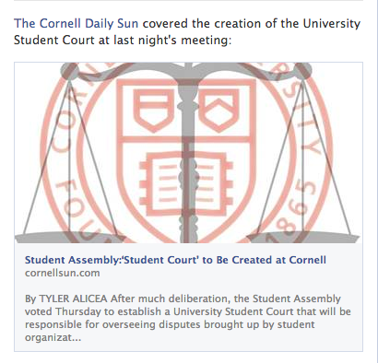
    - Using personal FB, post summary to page. Also, include link to Daily Sun if applicable:

    - Email above groups in Section I.A.iii. of resolution’s passing and how it affects them

The Student Assembly passed "Resolution 45: Fostering A United Student Body" in the spring of 2013. Cornell's registered student organizations are required to create a plan addressing diversity and inclusion for their organizational community. USB is being unveiled on a gradual basis to allow for more effective implementation. In its first year, byline funded organizations and SAFC performance tier organizations will be the first student groups to comply. For more information, please reach out to Cameron Pritchett cjp99@cornell.edu or check out CornellUSB.com.

    - VP of Public Relations will invite representative to filming of SA Video Update
      - This should be filmed on a bi-monthly basis (work to create a schedule)
      - Slope Media will come to Communication Committee or after the SA meeting each week
      - A short, catchy, high-quality 30-second video
      - 2-3 SA members, administrators, or community members will be featured in the video
      - Distribution Methods
        - Individual reps featured in the video will post it to the Cornell SA Facebook group, Class of 201X group, respective College/community group

- Publicizing Outreach Events
  - Attend Communications Committee
    - Assign Communication Committee graphic design members to create:
      - Quarter cards
      - Cover photo
      - Facebook event
This ensures consistent branding of the Student Assembly, eases some responsibility off of SA members who are not able to design communications, and allows for collaboration and brainstorming between committee members and representatives

    - Posting to Facebook
      - Individual reps post to the Cornell Student Assembly Facebook page
      - Post to Class of 201X group, college specific groups, organizations, etc.
      - Follow up after event with specific takeaways and next steps you are taking

    - Email List Serves
Follow steps outlined in sections II A i-v. for advertising to specific groups.

  - Reach out to Vice President of Public Relations
    - Before the event if you would like Cornell Sun to write an article promoting event or Slope Media filming the event
    - After, depending on the scale and outcome, have the Cornell Sun write a summary of the event

- Working With Individuals with Ideas for Resolutions
  - Ask student questions and take down contact information for future follow up
  - Invite student(s) to SA Office hours on Wednesday or Thursday to flesh out idea and draft up a resolution
  - Refer student to proper committee and attend meeting with student in order to get resolution approved
  - Invite student to SA Meeting and present resolution with them

- Committee Chairs
- At least 24 hours before meetings, Committee Chairs are required to create post (under the SA name) announcing committee, time, location, and point people to contact
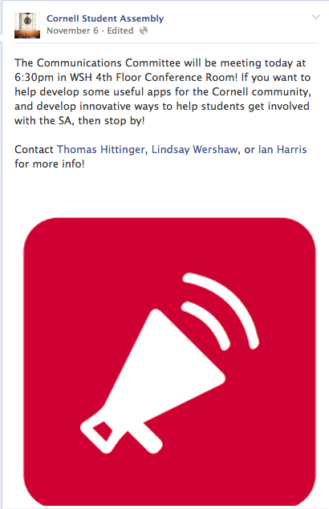

- Communications Committee
Will offer the tools, resources, and guidance for reps to promote their initiatives and events. This will create a consistent image and brand for the Student Assembly. Representatives are responsible for utilizing and consulting with the committee to learn best practices and perform their promotional responsibilities.

- SA Video Update
- Responsible for inviting reps, administrators, and community members to film
- Work with reps to distribute the video on Facebook, to list serves, etc.
- Facebook Updates
- Brainstorming Focuses
    - Initiatives (Current Progress)
      - Purpose: To showcase the resolutions, items, and projects the SA undertakes on a weekly basis
      - Example: “Cornell students, the SA is debating Resolution 26 about student safety at today’s SA meeting. Comment below.” / Press Release linked to sponsoring SA Members
    - Recognition
      - Purpose: To demonstrate that the SA recognizes students, student representatives, and student organizations that demonstrate exemplary characteristics.
      - Example: SA In the News, Organization Spotlights
    - Outreach
      - Purpose: To demonstrate that the SA recognizes students, student representatives, and student organizations that demonstrate exemplary characteristics.
      - Example: “Big shout out to the Cornell Democrats and College Republicans for the Rock-the-Vote event later on today. Thanks to SA reps X and Y for help setting up.”
    - Resolution and Agenda
      - Purpose: To showcase the resolutions, items, and projects the SA undertakes on a weekly basis
      - Example: “Cornell students, the SA is debating Resolution 26 about student safety at today’s SA meeting. Comment below.” / Press Release linked to sponsoring SA Members
To increase posting activity on the website, the following rules will be put into place:
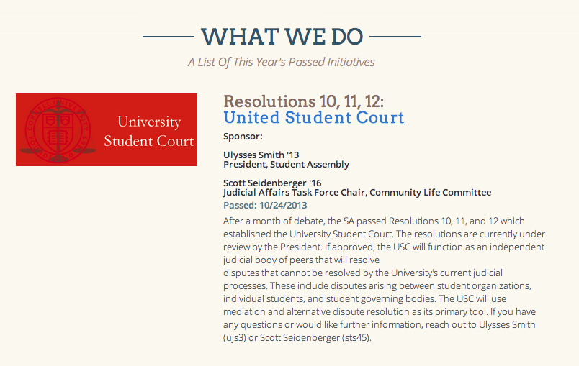
- For every resolution item, there must be a post on CornellSA.com summarizing the main idea and purpose. 1 Communication Committee member will be tasked with obtaining a summary from the sponsors after the resolution is passed.

- 1 Communication Committee member must regularly post SA In the News to the site.
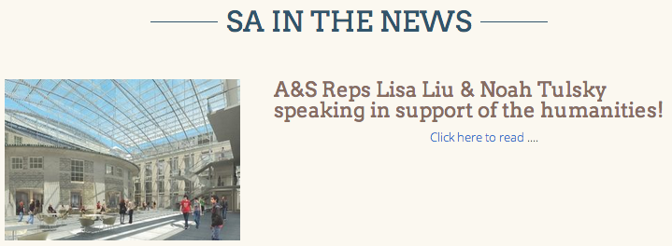

- Working with reps to publicize outreach events
    - Creation of consistent branding on Facebook, quarter cards, messaging
      - Representatives should be attending Communications Committee to work with the committee members to create advertisements and promotional material in order to ensure a consistent message is being sent to all students
    - Tabling & Quarter Carding
      - Community members and SA members can be assigned this task. In person interaction with fellow undergraduates will be used for the most important SA engagement objectives such as promoting outreach events.

- Organizational Spotlight

- The Student Assembly would like to recognize outstanding Cornell Student Organizations whose members work hard to make significant contributors to our campus community as builders, connectors and leaders.

- Each week, 1 club's members will be invited to Willard Straight hall at 4:30pm for Coffee Hour and then attend the SA meeting...

- Share best practices, reward groups excelling, talking across differences
- Next steps:
  - Meet with X Organization:
    - Tell me about your organization
    - Highlight a few significant things (events, advocacy campaigns) you’ve done
    - Areas you’ve improved over the year
    - Future vision of organization
    - If you had an additional $250, what would you do with it?
    - If the SA could do one thing for you, what could it be? (Ex: to facilitate a meeting with President Skorton or Susan Murphy to discuss issue salient in community, to do the Pie Toss event with us, help us plan X event)
    - From response, put together blurb or article
- Implementation
  - Cornell Sun has agreed to write an article announcing the launch of this initiative
  - At the end of each month, Cornell Sun will highlight featured Organizations
  - If you ever feel like a group deserves to be recognized, invite an organization/person to Communications Committee
  - Any community member is able to recommend organizations for recognition

- Creation of SA Promotional Items
    - Will create and distribute promotional items to increase brand recognition and provide more brand exposure for the Student Assembly and resolutions it passes.
      - Used to recognize special events, build recognition, promote image
      - Items will be passed along from peer to peer, will serve as daily reminders of the SA, helps students serve as walking billboards, and rewards involvement
        - Ex: After adoption of Resolution 16: Government Pre-enrollment, creation of SA pads of paper or pencils or pens
      - Joint promotional efforts between the strengthen relationships between the SA and other organizations. These items make a statement about our commitment and collaboration with other groups on campus.
    - Evaluation Guidelines
      - Define target audience/organization
      - Create gear
      - Plan distribution method
      - Implement the promotion
      - Evaluate the results

    - For Members
      - Promotional items will be created increase unity, cohesiveness, and recognition of reps on the assembly
        - Ex: all first year reps get coffee mugs

- Vice President of Public Relations
- Internal
- Member education
- Training for dialogue with press
- Teach R.A.P. (Representative Action plan)
- Guidelines for Co-Sponsorship With SA
- Recurring Facebook Announcements
  - Office Hours
  - President Skorton & Susan Murphy Meeting
- External
- Point person to communicate with the press
- Serve as editor of SA Monthly Newsletter
  - Sent on the 1st of each month to all undergraduates
  - Include the past month’s accomplishments and next month’s plans accompanied by the contact person to whom comments and questions may be addressed
- Build relations with multimedia groups
  - Look to collaborate on projects such as SA Video Update and Organizational Spotlight
- Lead communications committee
  - Work to ensure a direct and present link between students active in campus government, administration, and students at-large
  - Assist in furthering outreach efforts of the Assembly
    - Aid in coordination of: community outreach forums, constituency events, etc.
    - Work to include more non-voting members in the decisions and events of the SA
  - Review all aspects of students’ concerns with information and technology
- Maintain website
- Work with Vice President of Finance during the Byline Funded year to publicize decisions
- Work with Director of Elections for elections’ advertising

- Mobile App Development
The Information Technology portion of the Communication Committee intends to act as a medium through which the Assembly can partner with student programmers to develop a range of meaningful, impactful mobile applications. IT Co-chair should work with Communications Committee to create an application process for how groups go about requesting apps and demonstrating need for this service. As a guideline, the IT Co-chair should be working to complete at least one app per semester:
Short Term:
- Continue overseeing programming team of Master’s of Engineering students to produce prototype Cornell Dining mobile application.
- Communicate with Cornell Dining to ensure needs are met, databases are created, and capabilities are increased to enable different features in the application.
- Solicit student opinion through the Cornell Dining Committee, survey results, and focus groups as needed.
- Present prototype to University administration in November.
- Refer to attached Phase III Report
Long Term:
- Determine unmet needs on campus that can be addressed through mobile application development. Work with student organizations to create new projects.
- Partner with PopShop, Information Science Student Association, Association of Computer Science Undergraduates, and relevant groups to continue high-quality technology development.
- Create new programs, through course work, internships, etc., to further organize programming capabilities through the University

