United Student Body

Student Assembly
Student Life Diversity and Inclusion Plan

Cornell University
Spring, 2013

(DRAFT v.2 – April 10th, 2013)

Presented by:

Adam Gitlin ’13
President, Student Assembly

Ulysses Smith ’14
Vice President for Diversity & Inclusion, Student Assembly
President-elect, Student Assembly

Juliana Batista ’16
Freshman at-Large Representative
Vice President of Outreach-elect, Student Assembly
Co-chair, Student Assembly Committee on Diversity and Inclusion Initiatives

Oscar Correia ’14
Co-chair, Student Assembly Committee on Diversity and Inclusion Initiatives
Co-chair, La Asociacion Latina

Ian Harris ‘16
Freshman at-Large Representative
Vice President of Public Relations-elect, Student Assembly

- Introduction

According to the 2011 Cornell PULSE Survey, 70% of students said they have “very often” or “often” socialized or shared a meal with students differing in race, national origin, sexual orientation and political views. Although this is a promising statistic, it only partially tells the story of students’ sense of diversity and inclusion, however.

Delving below the surface, 38% of students said that “they [occasionally] felt out of place or that they didn’t fit on campus,” 10% said they “often felt” out of place and 6% responded saying they felt this feeling “often” in interactions with diverse students. Perhaps even more striking, furthermore, is that 16% of the student body stated they “occasionally” have felt insulted or threatened based on their social identity, 5% said “often” and 4% answered “very often” - together adding up to one in four members of the student body.

Students endorse Cornell’s 2000 “Open Doors, Open Hearts, Open Minds” statement and agrees with the goals outlined in President Skorton’s statement on diversity in 2012. The student body, furthermore, believes the university’s Toward New Destinations plan has laid the foundation to increase institutional diversity at Cornell. Other offices, divisions and resources for students, such as The Center for Intercultural Dialogue (626), The Office of Academic Diversity Initiatives (OADI) have also laid the foundation for a greater sense of community on campus and one that fosters the greatest sense of diversity and inclusion for all students.

But the initiatives cannot end on an institutional level. Student leaders across this campus must also embrace principles of diversity and inclusion. The notion of diversity is a multi-faceted concept: it encompasses diversity of thought, diversity of culture or diversity of belief. The student body is composed of individuals from different backgrounds, ethnicities, religions and hometowns from each of the fifty states and from around the world. Students identify with different gender identities, have disabilities, have different color skin, speak different languages and appreciate different customs. Student leaders of every community on campus, therefore, must also engage in the process of making student life at Cornell a more diverse experience, one that fosters the appreciation of differences that exist within the student body and reflect our country.

Most – if not all – student leaders are in favor of their organizations becoming more inclusive and becoming more diverse. Many student leaders, however, do not necessarily have the tools or know where to start. Cornell is a large, often-decentralized campus and there are many isolated communities. United Student Body will provide students with the framework to implement diversity and inclusion initiatives and to bring the student body together across all activities and clubs that are the crux of student life.

- Menu of Annual Student Life Initiatives

In honoring and keeping with the above commitments, the Student Assembly asks that each student organization create a Diversity and Inclusion Plan (DIP) by selecting three Annual Initiatives from the menu below and incorporating them into the activities of their organization. The DIPs will strengthen organizations and the activities they carry out by connecting communities and bringing activities and events to different places on campus.

Each organization is different and engages in distinct activities. The activities of campus literary journals are different from the activities of a cappella groups, sustainability organizations or pre-professional fraternities. Thus every organization’s DIP will likely be different and reflect the nuances of each organization and the work they carry out each semester. United Student Body is meant to give students flexibility in determining which diversity and inclusion initiatives are best for their organization. The S.A. will not determine what is the best route for any one organization. All organizations over time will implement diversity and inclusion initiatives because all groups ought to share a common thread of appreciating the diversity that exists within the student body.

- Composition: working to make sure that the student organizations take specific action steps to offer involvement, participation, and membership and make sure the demographic makeup of the student organization reflects the diversity of the student body.

- Increase the effectiveness of communication and recruitment around diversity: increase the visibility and influence of the student organizations’ messaging, recruitment, and collaboration among many communities. Seek to increase the diversity of your student organization. Seek to appeal and invite the broader Cornell community and seek to assess the venues and media methods that the organization recruits virtually and in-person.

- Increased targeted pipelines: develop or enhance relationships with strategic partners, student leaders, students organizations, and communities. Assure that every year organizations are maintaining a commitment to recruit from diverse communities – that the partnership becomes an operational and social norm.

Initiatives:

- Email diverse student organizations and communities with recruitment blurbs during formal recruitment.

- Present at pertinent events, general body meetings.

- Organize recruitment events at diverse organizations.

Examples:

- Email targeted organizations and student leaders during formal recruitment with publicity about the organization’s recruitment period. Organizations include:
- Africana, Latin American, Asian American, and Native American (ALANA)
  - The Umbrella Organizations: Black Students United (BSU), La Asociación Latina (LAL), Cornell Asian and Asian American Umbrella Organization (CAPSU), Native American Students at Cornell (NASAC).
- Haven: The LGBTQ Student Union
- Women’s Resource Center
- Renee Alexander, or an appropriate contact at 626 Thurston, The Intercultural Center at Cornell University.
- Office of Academic Diversity Initiatives (OADI)
- International Students and Scholars Office (ISSO)

- Present at pertinent events around campus to discuss the work and opportunities within your student organization. Example of events include but are not limited to:
- Ujamaa’s Unity Hour
- LAL’s Cafe con Leche
- OADI’s Tuesday Lunch Engagement Series
- American Indian Program (AIP) Wednesdays Soup Day Speakers & Luncheons
- Haven: The LGBTQ Student Union Sunday brunch meetings
- Thursday Lunch Series at 626 Thurston, The Intercultural Center
- Scholars Working Ambitiously to Graduate (SWAG) monthly meetings
- Religious organizations’ meetings: Committee for the Advancement of Muslim Culture (CAMC), Cornell Hillel, The Catholic Fellowship, among others.
- Coffee Hour - have members from organization attend and informally talk about it or request that content relating to respective student organization is used as a discussion topics.

- Engagement: Ensuring that students of all identities and backgrounds experience the full range of dynamic and stimulating exchange across difference within student organizations’ activities.

- Support and expand a culture and strengthen activities and initiatives promoting engagement across difference: increase communication, offerings, and events that provide exposure to and information on engagement across difference.

- Expand collaboration and intellectual initiatives around diversity: highlight and encourage activities, intellectual work and conference presentations on topics relevant to the study of diversity.

Initiatives:

- Collaborate with different student organizations to plan events that will appeal to the broader Cornell community.

- Have scholarships for events or activities that are not financially accessible to all students.

- Plan events and meetings that are accessible to people with disabilities.

- Form mentorship programs to provide current members not only with an outlet but also engages members across the organization from different backgrounds.

Examples:

- When planning a banquet, make the dress code less formal so that having the right clothing is not prohibitive on attendance.

- Write a statement on all advertisements with contact info regarding making accessibility accommodation requests. For example: “We strive to make our events accessible. For accommodation requests please contact abc123@cornell.edu.” Or alternatively, “We strive to make our events accessible to all students regardless of financial need. Please contact abc123@cornell.edu if you would like to speak about the financial constraints of the activity.”

- If planning a trip to a conference ask students if they would be willing to donate to a fund for students that might not be able to afford to go without support.

- Inclusion: cultivating an environment in which students of all identities and backgrounds feel welcomed, included, and at home in the student organization’s opportunities activities.

- Highlight and advance an appreciation of the relevance of diversity to excellence in student activities: promote inclusion on the significance of diversity in student activities and support awareness of the catalyzing effects of difference.

- Support leadership development for a target area or constituency: increase the diversity of participants in leadership training, student leadership positions, conference participation, rewards and recognitions, strategic planning.

Initiatives:

- Choose event themes that foster a sense of diversity and inclusion that allow for all people to be represented.

- Review and ensure that titles, tag-lines, and slogans of events refrain from exclusionary language that ostracize communities on campus.

- For journals, incorporate articles that emphasize diversity or appreciate different cultures and identities.

- Invite various organizations to co-sponsor and take part in organizing events.

- Physically transfer the location of organization’s event to a location that represents a different constituency or niche of campus.

Examples:

- Inclusive themes: Sustainability Hub’s Earth Day theme, “The Faces of Sustainability” or the Student Assembly’s “Know the Power of Your Words” event which featured a panel where students spoke about their experiences dealing with incidents of gender, race, religion, disability and sexual orientation bias.

- A concert collaboration between the Glee Clubs of Morehouse College and Cornell University.

- Accountability and Enforcement

In order to assure that organizations are upholding the values of diversity and inclusion, the Student Assembly will partner with the Student Activities Office. The Student Assembly Organization Review Subcommittee (SAORS) – which will be a subset of the Student Assembly Committee on Diversity and Inclusion Initiatives (SACIDI) – will review organization’s selected menu items within their Diversity and Inclusion Plans.

The following changes will be made to the charge of the SACIDI to implement the S.A.’s Student Life Diversity and Inclusion Plan. (Please note: the numbering is based off of the Student Assembly Resolution 45 “Building Better Committees” which aims to restructure S.A. committees. The resolution has not passed yet though.)

ARTICLE VI: Committees

Section 4: Student Interests

3) Student Assembly Committee for Inclusion and Diversity Initiatives (SACIDI)

Student Assembly Organizational Review Subcommittee (SAORS) - The Organizational Review Subcommittee (SAORS) is a subcommittee of the Student Assembly Committee on Diversity and Inclusion initiative. SAORS will be charged with reviewing new and current student organization’s Diversity and Inclusion Plans (DIPs). The SAORS shall be chaired by an assembly member, staffed by the Student Assembly Vice Presidents of Outreach and Diversity and Inclusion, chairs of the S.A. Committee on Diversity and Inclusion Initiatives (SACIDI) and S.A. Diversity Affairs Coalition two more assembly members and include five community members. Quorum is eight voting members. Each member of SACIDI will nominate a member to the SAORC. Each member of the committee will take part in an annual training overseen by the S.A. VP of Diversity & Inclusion.

Diversity and Inclusion Plan (DIP) Review Process: The function of the committee is (1) to review an organization’s proposed DIP, (2) approve the DIP or encourage the organization to make changes if necessary, (3) review the extent to which the organization carried out its DIP.

Diversity and Inclusion Plan Timeline: All DIPs are due prior to Fall Break in the Fall semester. The SAORC will review the DIPs and either approve or make recommendations if necessary.

Approving an Organization’s Diversity and Inclusion Plan: the SAORS will approve an organization’s DIP if it has satisfied the criteria of the Student Assembly’s Student Life Diversity and Inclusion Plan. The student organization must select at least three menu items and implement them over the course of the academic year. For the review process, the committee must notify the group that it is being reviewed by the SAORS. The committee must give student organization’s the opportunity to meet with a representative of the SAORS if they need help choosing menu initiatives or would like to review any ideas with regard to their DIP.

Recommending Changes to an Organization’s DIP: if members of the SAORS believe a student organization’s DIP should be changed because it does not sufficiently fulfill the principles and standards outlined in the S.A.’s Student Life Diversity and Inclusion Plan, it can send the organization’s leadership its recommendations if it passes the committee by a majority vote. However, the committee will defer to the organization’s DIP under most circumstances because they are more familiar with the activities and initiatives of the organization. If deemed necessary, one member of the committee may attend the organization’s meetings to learn about the organization’s membership and the organization’s dynamics. If necessary, the committee may require (1) a list/count of their members, a list/count of the members on their listserv, a list/count of the individuals who attended their largest event each semester, (2) a summary of their activities in the last four semester, (3) a spreadsheet with their revenues per funding sources and expenses per activity, and (4) a calculation of their SAFC funding per member.

Recommending Removal of SAO Recognition: if the committee has determined that (1) a student organization does not intend to create a DIP or (2) did not in a good faith manner attempt to implement its proposed DIP, it has the right to recommend to the Student Assembly that the organization should lose its right to be an SAO-recognized student organization. Upon completion of the review process, the committee must have a four-fifths majority to revoke an organization’s RSO recognition and must submit a written statement to both the Student Assembly and the organization detailing the proceedings. The group may appeal the committee’s decision to the Student Assembly.

- Implementation Plan

- Selection of Diversity and Inclusion Initiatives

All student organizations will able to download a document with the examples of diversity initiatives above, among many others, in order to plan which initiatives they will enact. The organization leadership will internally discuss which initiatives will be best suited for their organization for the academic year.

The Student Assembly Vice President of Diversity and Inclusion as well as members of the Student Assembly Organizational Review Subcommittee (SAORS) and the Student Assembly Committee on Diversity and Inclusion Initiatives (SACIDI) will hold Skype office hours over the summer and in person office hours at the beginning of the school year. Organization leadership will have the opportunity to discuss their Diversity and Inclusion initiatives with members of the committee.

- Logistics

Upon applying to be a student organization, officers would include which initiatives they plan to enact during the academic year.

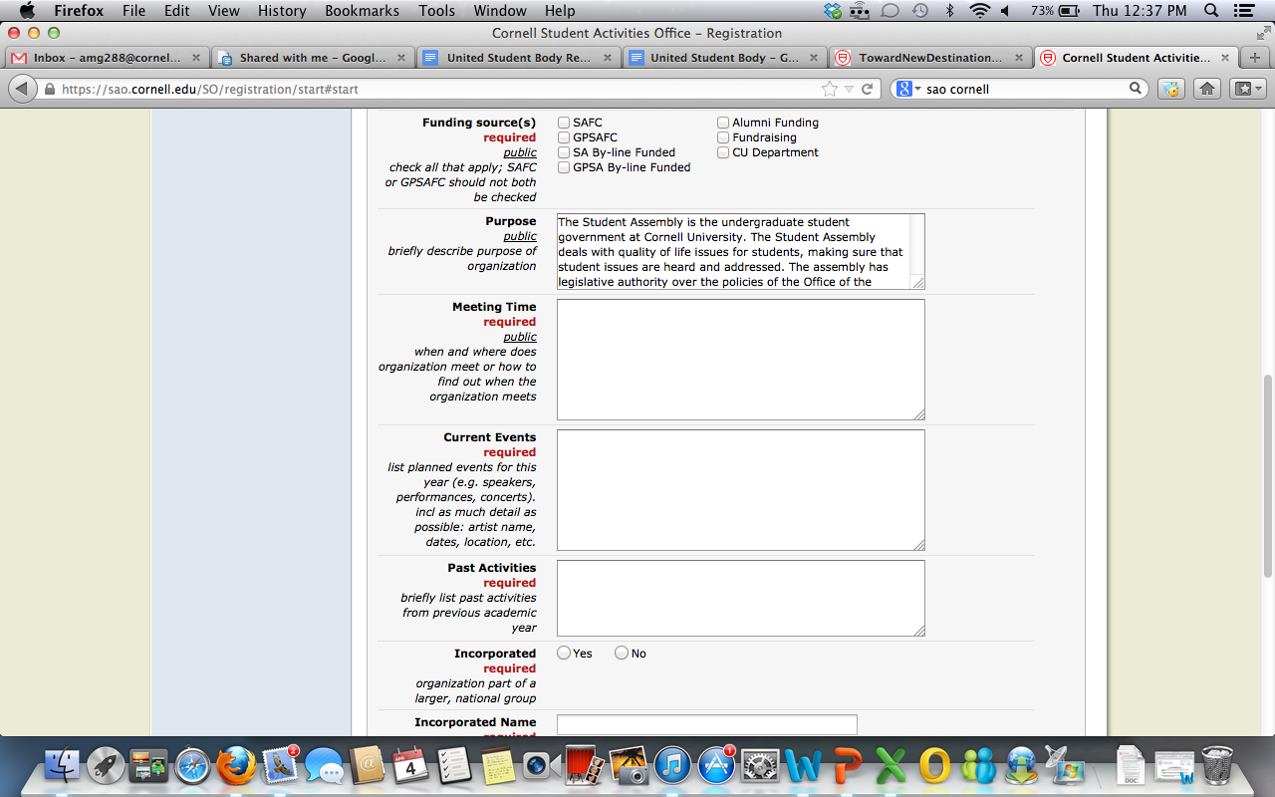

- Timeline

United Student Body will be phased in over the course of a few years in order to assure that it is properly implemented. Tentatively, the groups in the Student Assembly Finance Commission’s (SAFC) “Performance Tier” will be the first organizations that will select diversity and inclusion initiatives under United Student Body. This will occur in the 2013-2014 academic year. The SAFC estimates that this number will be a small number of organizations relative to the overall number of SAO organizations. Every year, United Student Body would apply to the subsequent funding tier.

The United Student Body plan would not affect any SAFC allocations or tier placements. Rather, the tier system was only used as a logical organizational tool and as a way to gradually implement the plan.

The breakdown of tiers – and the academic year during which United Student Body would apply – is below:

Tier | Number of Organizations | USB Implementation
“Performance” tier | n/a | 2013-2014
$4000 tier | - | 2014-2015
$3250 tier | - | 2014-2015
$2500 tier | - | 2015-2016
$1750 tier | - | 2016-2017
$1000 tier | - | 2017-2018

Please note: the number of organizations in each SAFC funding tier is confidential and therefore not included in this document.

- Measurement of Success and Metrics

The Student Assembly could collaborate with the Office of Institutional Research and Planning or the Department of Inclusion and Workforce Diversity to assure that it is accurately tracking trends in the opinions of the student body.

There are two potential metrics that the Student Assembly could measure the success of United Student Body. The first option is observing the changes in the Cornell PULSE survey, which is measured every other year. The survey asks the extent to which students feel comfortable socializing and interacting with students differing in race, national origin, sexual orientation and political views, among other characteristics, during their time at Cornell. Additionally, the survey asks whether they feel “out of place” on campus in interactions with diverse students or whether students have felt insulted or threatened based on their social identity. The Student Assembly could measurably track the changes in these survey questions over time.

A second potential metric is asking that all organizations instruct their membership to complete a survey at the beginning of the academic year. The survey will ask questions measuring the extent to which members feel included and engaged based on the activities of the organization or the extent to which the composition of the organization reflects the diverse student body at Cornell. This data could then be used as a base line for subsequent surveys. The data could also allow organization leadership to identify particular diversity and inclusion initiatives that they might want to choose to include and engage all communities on campus.

