Appendix B to S.A. Resolution #36

ADDITIONAL DETAILS:

→Needs specific to International Students include, among many others:

- Language problems,
- Cultural differences (including alimentary, social and more),
- Culture shock,
- Financial difficulty of living so far from home country and for so long,
- Stark differences in education systems,

→Other current specific student & resource centers present at Cornell:

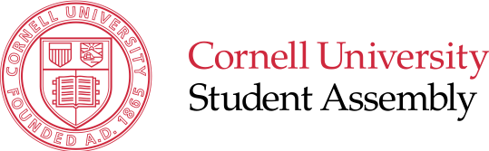
- AIP, American Indian Program. From the website, American Indian students and organizations “have a home on the fourth floor of Caldwell Hall, complete with new computers, a study and research area, and room for students to work on group projects”.
- LSP, Latino Studies Program. “The Latino Studies Program is located on the fourth floor of Rockefeller Hall and includes administrative offices, library/study lounge, film collection, computer lab, and conference room”.
- Several other centers catering to other students, not just transculturally (e.g. LGBT Resource Center).

→ The Holland International Living Centre (HILC) is a program house with a very good international focus on North Campus. It houses mostly freshmen, a portion of which international. >>As such it is comparable to Akwe:kon, Ujamaa or the Latino Living Center.

