Institution | Fund Name | Established | Fund Size | Projects | ROI
Western Michigan University | Quasi GRF | 1980 | $365,000 | 101 | 47%
Harvard University | Green Loan Fund | 2001 | $12,000,000 | 185 | 30%
University of Utah | Energy Office Conservation Program | 2007 | $220,000 | 47 | 30%
Iowa State University | Live Green Revolving Loan Fund | 2008 | $3,000,000 | 11 | 29%
Oberlin College | Green EDGE Fund | 2008 | $40,000 | 9 | 31%
University of Colorado- Boulder | Energy & Climate Revolving Fund | 2008 | $500,000 | 5 | 38%
Caltech | CICEP | 2009 | $8,000,000 | 13 | 33%
Resolution 15 Appendices

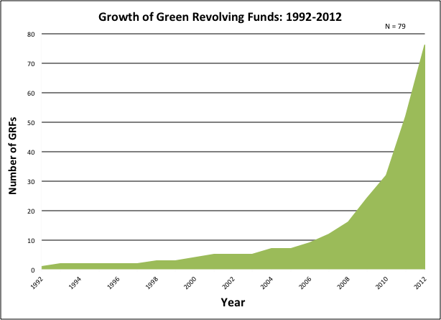

Types of Projects
- Lighting and water efficiency retrofits
- Low flow showerheads/toilets
- Bulb replacement
- Energy saving software
- Motion Sensors
- Composting equipment
- Converting vehicles to run on biofuels
- Easy access insulation
- Local energy generation

GRF By the Numbers
- 75 institutions operating 79 funds
- $112 million in self managed GRFs
- 33 states and 2 Canadian provinces
- Median annual ROI of 29%

