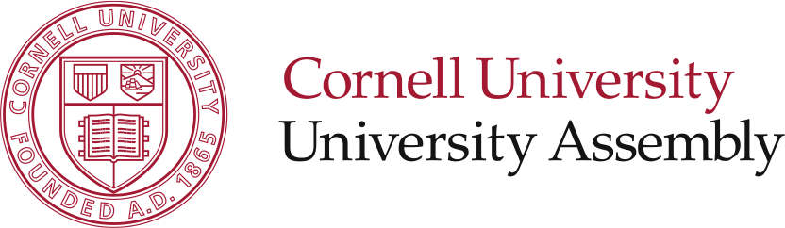 |  |  | 109 Day Hall  p. 607.255.3715  f. 607.255.2182  e. univ_assembly@cornell.edu  w. http://assembly.cornell.edu/UA
February 13, 2008

President David J. Skorton
Cornell University
300 Day Hall

Dear President Skorton:

The charter of the University Assembly (UA) states that the UA has “legislative authority for those aspects of the conduct of member of Cornell University now covered by the Campus Code of Conduct…” At it’s 14 November 2007 meeting, the University Assembly passed a revised version of the Campus Code of Conduct and, on 20 November 2007, sent it to you for your comment and action. On 20 December 2007, you indicated your intention to communicate your own and your senior leadership’s comments and judgments concerning the UA’s “recommended changes to Campus Code.”

On 4 February 2008, you responded to the University Assembly with said comments and judgments on the revised code, indicating your acceptance of all the UA’s revisions of the Campus Code except the following:
- Three ”procedural issues” ”requiring modification”, two “not accepted’, and one “requiring further review”;
- One “penalties” issue “requiring modification”;
- One jurisdictional issue “requiring modification”;
- One “other” issue requiring “modification”.

The Charter of the University Assembly stipulates that the “UA shall respond to any requests from the President for information or reconsideration of any actions.” Thus, following standard procedures for changes to the Campus Code of Conduct, we have submitted your comments to our Codes and Judicial Committee (CJC). The Cornell University Counsel has an ex-officio seat on this committee, and we invite you and the University Counsel to participate in the scheduled CJC meeting on Monday (18 February, 4:30 – 6:30 pm in 316 Day Hall) and subsequent meetings of that committee to discuss the administration’s request for revisions and reconsiderations regarding the revised code. It is the UA’s recommendation that the CJC, not the President’s working group, is the best body to discuss further revisions to the code because of the CJC’s prior extensive experience and knowledge.

The CJC will report the results of its work to the UA no later than 15 March 2008. The UA will consider and act on the committee’s recommendations at its 26 March 2008 regular meeting and convey the results of its action to you at that time.

Respectfully submitted,

Rodney A. Orme on behalf of:

The University Assembly and
The University Assembly Codes and Judicial Committee

Approved by the following members of the
University Assembly Approved by the following members of
Employee Members: the University Assembly Code and
Bill Liddick Judicial Committee
Rodney Orme Faculty Members:
Faculty Members: David Kay
Marty Hatch Kevin Clermont
David Rosen Employee Members:
Elizabeth Sanders Kathleen E. Rourke
Randy Wayne Kathy Zoner
Ellis Lowe Graduate Student Members:
Undergraduate Members: Andrew Cowan
Christopher Basil
Mark Fontana
Alex James
David Kurczewski
Jules Marwell
Steven Matthews
Graduate and Professional Student Members:
James Glenn
Tamara Pardo

cc: James J. Mingle

